Chapter 5, Problem 24

In the circuit shown in Fig. 5.62, find k in the voltage transfer function v_{o} = kv_{s}.

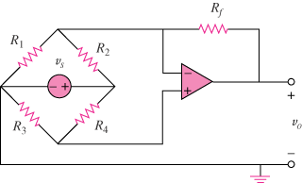

Figure 5.62
For Prob. 5.24.

